Out of abundance of caution, CASA for Lancaster County would like to share the following information regarding the Coronavirus (COVID-19) and what steps the organization is taking to ensure the health and safety of all staff and volunteers. Until further notice, CASA for Lancaster County will be following the World Health Organization and the Center for Disease Control recommendations regarding the Coronavirus/COVID-19

The recommendations are as follows:

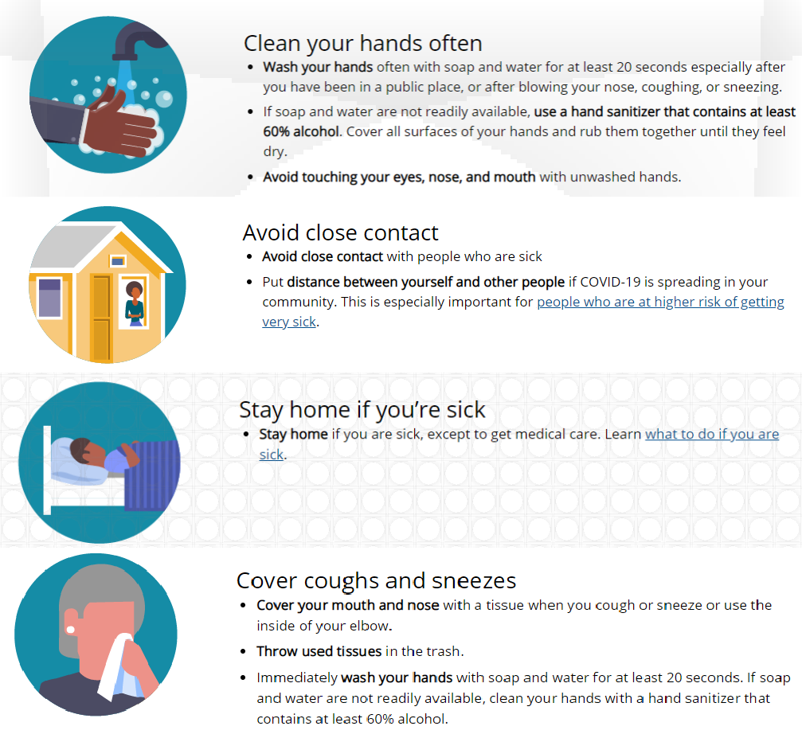

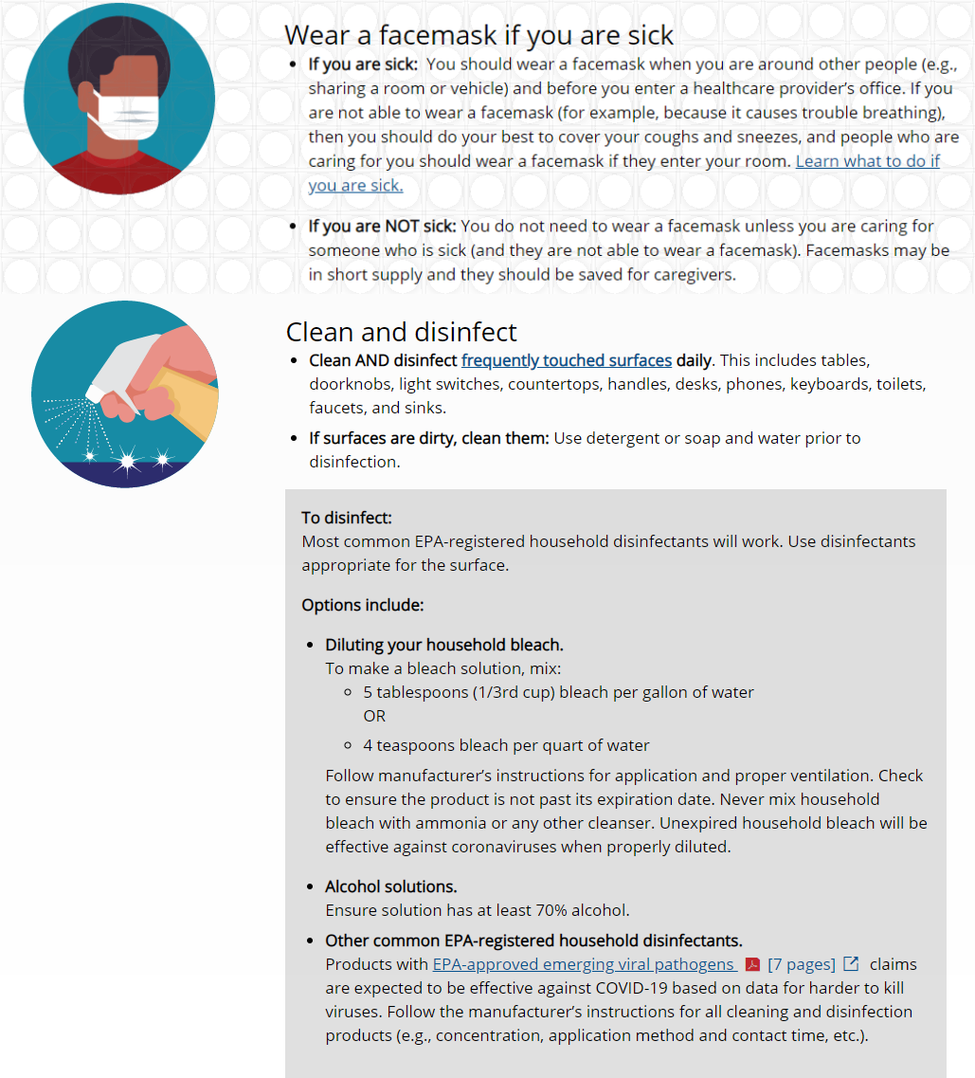

CASA for Lancaster County is encouraging all staff and volunteers to follow the above stated protocol and protect themselves to avoid possible transmission of the Coronavirus. In addition, the CDC has recommended limiting exposure in group settings and avoid meeting in public places until it is deemed safe to return to regular procedures.

CASA is recommending the following specific guidelines for CASA Volunteers and staff:

- Limit visits to schools and large public gatherings when attempting to conduct your monthly visit with your CASA child(ren).
- Before meeting with children make sure to ask general health questions (of the child and/or caretaker):
  - Phone or online contact with CASA children is acceptable during this time – we will not require you to visit your CASA children in person.
  - Have you, or anyone in your home, been out of country in the last 14 days?
  - Have you come into contact with someone who has tested positive for COVID-19 in the last 14 days?
  - Do you have a fever or symptoms of a lower respiratory illness?
- Use virtual meeting options (i.e. Zoom/Facetime/Skype) or phone calls for Family Team Meetings or meetings with other case professionals.

CASA Staff - If you become exposed to someone with the Coronavirus/COVID-19, please tell your supervisor immediately, conduct the self-screening assessment and follow your healthcare provider’s recommendations. Any staff exposed to Coronavirus/COVID-19 will be asked to self-quarantine for 14 days or as long as the CDC recommends. For these instances there will be a work from home policy implemented. If you have a fever or cough, CASA for Lancaster County asks that you not return to work for at least 24 hours after the fever and/or cough has subsided without the use of medicines (i.e. fever reducers or cough suppressants).

CASA for Lancaster County wants to ensure safety for all staff and volunteers, if you have any questions or concerns please contact the CASA Office (402) 474-5161.

Sincerely,

Dawn Rockey, Executive Director
CASA for Lancaster County

